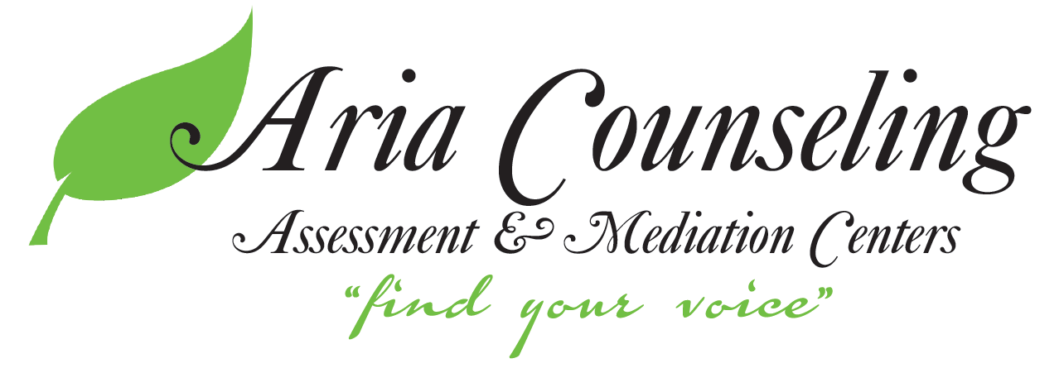
7260 University Avenue NE
Suite 235
Fridley, MN 55432

3249 Hennepin Ave S, Suite 144
Minneapolis, MN 55408

admin@ariacounselingmn.com
www.ariacounselingmn.com
Phone: (763) 572-2612
Fax: (763) 572-2606

--------------------------------------------------------------------------------------------------------------------------------------------

Informed Consent for Telehealth Services

Definition of Telehealth
Telehealth involves the use of electronic communications to enable mental health professionals to connect with individuals using interactive video and audio communications.
Telehealth includes the practice of psychological health care delivery, diagnosis, consultation, treatment, referral to resources, education, and the transfer of medical and clinical data.
I understand that I have the rights with respect to telehealth:
1. The laws that protect the confidentiality of my personal information also apply to telehealth. As such, I understand that the information disclosed by me during the course of my sessions is generally confidential. However, there are both mandatory and permissive exceptions to confidentiality, including, but not limited to, reporting child, elder, and dependent adult abuse; expressed threats of violence toward an ascertainable victim; and where I make my mental or emotional state an issue in a legal proceeding. I also understand that the dissemination of any personally identifiable images or information from the telehealth interaction to other entities shall not occur without my written consent.
2. I understand that I have the right to withhold or withdraw my consent to the use of telehealth in the course of my care at any time, without affecting my right to future care or treatment.
3. I understand that there are risks and consequences from telehealth, including, but not limited to, the possibility, despite reasonable efforts on the part of the counselor, that: the transmission of my personal information could be disrupted or distorted by technical failures, the transmission of my personal information could be interrupted by unauthorized persons, and/or the electronic storage of my personal information could be unintentionally lost or accessed by unauthorized persons. CFS utilizes secure, encrypted audio/video transmission software to deliver telehealth.
4. I understand that if my counselor believes I would be better served by another form of intervention (e.g., face-to-face services), I will be referred to a mental health professional associated with any form of psychotherapy, and that despite my efforts and the efforts of my counselor, my condition may not improve, and in some cases may even get worse.
5. I understand the alternatives to counseling through telehealth as they have been explained to me, and in choosing to participate in telehealth, I am agreeing to participate using video conferencing technology. I also understand that at my request or at the direction of my counselor, I may be directed to “face-to-face” psychotherapy.
6. I understand that I may expect the anticipated benefits such as improved access to care and more efficient evaluation and management from the use of telehealth in my care, but that no results can be guaranteed or assured.
7. I understand that my healthcare information may be shared with other individuals for scheduling and billing purposes. Others may also be present during the consultation other than my counselor in order to operate the video equipment. The above-mentioned people will all maintain confidentiality of the information obtained. I further understand that I will be informed of their presence in the consultation and thus will have the right to request the following: (1) omit specific details of my medical history that are personally sensitive to me, (2) ask non-clinical personnel to leave the telehealth room, and/or (3) terminate the consultation at any time.
8. I understand that my express consent is required to forward my personally identifiable information to a third party.
9. I understand that I have a right to access my medical information and copies of my medical records in accordance with the laws pertaining to the state in which I reside.
10. By signing this document, I agree that certain situations, including emergencies and crises, are inappropriate for audio-/video-/computer-based psychotherapy services. If I am in crisis or in an emergency, I should immediately call 9-1-1 or seek help from a hospital or crisis-oriented health care facility in my immediate area.
11. I understand that different states have different regulations for the use of telehealth. In Wisconsin, telehealth may only be conducted between certified office locations. I understand that, in Wisconsin, I am not able to connect from an alternative location for the provision of audio-/video-/computer based psychotherapy services.

Payment for Telehealth Services
Aria Counseling, Assessment & Mediation Centers will bill insurance for telehealth services when these services have been determined to be covered by an individual’s insurance plan. In the event that insurance does not cover telehealth, the individual wishes to pay out-of-pocket, or when there is no insurance coverage, a prompt pay discount is available. We will provide you with a statement of service to submit to your insurance company if you wish.

Patient Consent to the Use of Telehealth
I have read and understand the information provided above regarding telehealth, have discussed it with my counselor, and all of my questions have been answered to my satisfaction. I have read this document carefully and understand the risks and benefits related to the use of telehealth services and have had my questions regarding the procedure explained. I hereby give my informed consent to participate in the use of telehealth services for treatment under the terms described herein.
By my signature below, I hereby state that I have read, understood, and agree to the terms of this document.
________________________________________________________________________
Print Name
_____________________________________________________ ___________________
Client’s Signature Date
_____________________________________________________ ___________________
Parent or Guardian Signature Date

